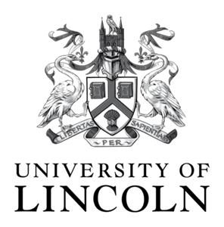
Women into Research 2015
Programme of events
Date | Time | Event | Speaker / Facilitator | Venue
28th Jan 15 | 12.30 – 13.30 | Seminar 1:  Why research? | Prof Sara Owen, PVC  Head of College of Social Science | MB3203
25th Feb 15 | 12.30 – 13.30 | Action Learning Set 1:  Perceived barriers to becoming research active | Dr Sarah Amsler,  Reader in the School of Education | MB3201
25th Mar 15 | 12.30 – 13.30 | Seminar 2:  Getting started with or without research funding | Dr Andrea Abbas  Head of the School of Education | MB3201
29th April 15 | 12.30 – 13.30 | Action Learning Set 2:  Doing research with no budget | Dr Zowie Davy,  Senior Lecturer in the School of Health and Social Care | MB3203 on 29th
27th May 15 | 12.30 – 13.30 | Action Learning Set: 3  Successful proposal | Dr Lisa Collins  Reader in the School of Life Sciences | MB3201
1st July 15 | 12.30 – 13.30 | Seminar 3:  CANCELLED
30th Sept 15 | 12.30 – 13.30 | Seminar 4:  Collaborative processes in research | Dr Basabdatta Sen Bhattacharya,  Lecturer in the School of Engineering | tba
28th Oct 15 | 12.30 – 13.30 | Action learning set 4:  Career Progression | Dr Aylwyn Walsh,  Lecturer in the School of Fine and Performing Arts | tba
25th Nov 15 | 12.30 – 13.30 | Seminar 5:  The Research Excellence Framework (REF) and the university | Dr Karen Windle,  Reader in Health | tba
16th Dec 15 | 12.30 – 13.30 | Final get together to celebrate the Women into Research Initiative at Christmas:  Future thoughts, ideas and networking | Dr Zowie Davy,  Senior Lecturer in the School of Health and Social Care | tba

Writing-up, dissemination and choosing a Journal Dr Jacqui Allen-Collinson??
For more information about dates and rooms numbers please contact: Dr Zowie Davy zdavy@lincoln.ac.uk you can also visit the Website http://womenintoresearch.blogs.lincoln.ac.uk/ for information, discussion and more.
Please note that lunch will be provided at all the events.

